***SQL Workshop***

**Practice 14 Solutions**

1. Create the tables based on the following table instance charts. Choose the appropriate data types and be sure to add integrity constraints.

1. Table name: MEMBER

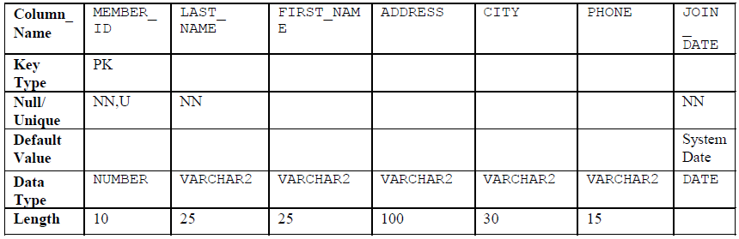

**CREATE TABLE member**

**(member_id NUMBER(10)**

**CONSTRAINT member_member_id_pk PRIMARY KEY,**

**last_name VARCHAR2(25)**

**CONSTRAINT member_last_name_nn NOT NULL,**

**first_name VARCHAR2(25),**

**address VARCHAR2(100),**

**city VARCHAR2(30),**

**phone VARCHAR2(15),**

**join_date DATE DEFAULT SYSDATE**

**CONSTRAINT member_join_date_nn NOT NULL);**

1. Table name: TITLE

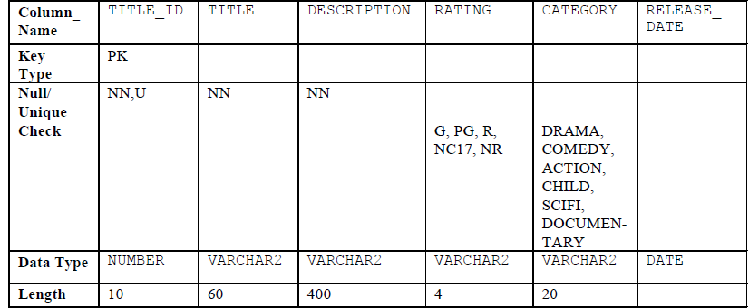

1. Table name: TITLE_COPY

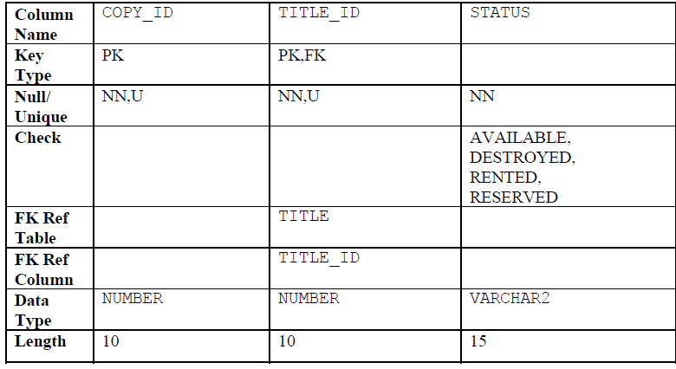

**CREATE TABLE title_copy**

**(copy_id NUMBER(10),**

**title_id NUMBER(10)**

**CONSTRAINT title_copy_title_if_fk REFERENCES title(title_id),**

**status VARCHAR2(15)**

**CONSTRAINT title**_**copy**_**status**_**nn NOT NULL**

**CONSTRAINT title_copy_status_ck CHECK (status IN**

**('AVAILABLE', 'DESTROYED','RENTED', 'RESERVED')),**

**CONSTRAINT title_copy_copy_id_title_id_pk**

**PRIMARY KEY (copy_id, title_id));**

1. Table name: RENTAL

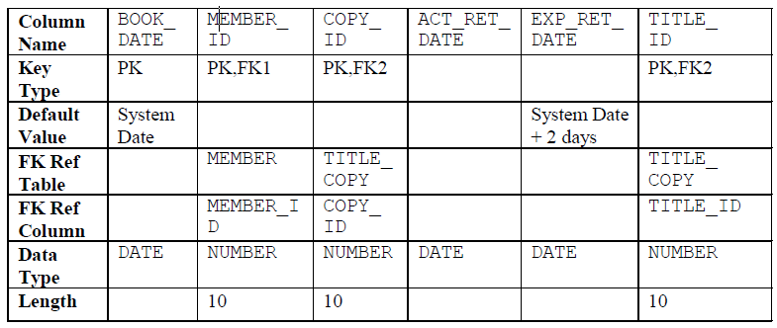

**CREATE TABLE rental**

**(book_date DATE DEFAULT SYSDATE,**

**member_id NUMBER(10)**

**CONSTRAINT rental**_**member**_**id**_**fk**

**REFERENCES member(member_id),**

**copy_id NUMBER(10),**

**act_ret_date DATE,**

**exp_ret_date DATE DEFAULT SYSDATE + 2,**

**title_id NUMBER(10),**

**CONSTRAINT rental_book_date_copy_title_pk**

**PRIMARY KEY (book_date, member_id,**

**copy_id,title_id),**

**CONSTRAINT rental_copy_id_title_id_fk**

**FOREIGN KEY (copy_id, title_id)**

**REFERENCES title_copy(copy_id, title_id));**

1. Table name: RESERVATION

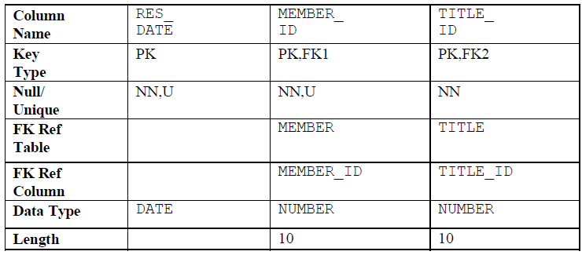

**CREATE TABLE reservation**

**(res_date DATE,**

**member_id NUMBER(10)**

**CONSTRAINT reservation_member_id**

**REFERENCES member(member_id),**

**title_id NUMBER(10)**

**CONSTRAINT reservation_title_id**

**REFERENCES title(title_id),**

**CONSTRAINT reservation_resdate_mem_tit_pk PRIMARY KEY**

**(res_date, member_id, title_id));**

2. Verify that the tables and constraints were created properly by checking the data dictionary.

**SELECT table_name**

**FROM user_tables**

**WHERE table_name IN ('MEMBER', 'TITLE', 'TITLE_COPY',**

**'RENTAL', 'RESERVATION');**

**SELECT constraint_name, constraint_type, table_name**

**FROM user_constraints**

**WHERE table_name IN ('MEMBER', 'TITLE', 'TITLE_COPY',**

**'RENTAL', 'RESERVATION');**

3. Create sequences to uniquely identify each row in the MEMBER table and the TITLE table.

a. Member number for the MEMBER table: start with 101; do not allow caching of the

values. Name the sequence MEMBER_ID_SEQ.

**CREATE SEQUENCE member**_**id**_**seq**

**START WITH 101**

**NOCACHE;**

b. Title number for the TITLE table: start with 92; no caching. Name the sequence

TITLE_ID_SEQ.

**CREATE SEQUENCE title**_**id**_**seq**

**START WITH 92**

**NOCACHE;**

c. Verify the existence of the sequences in the data dictionary.

**SELECT sequence_name, increment_by, last_number**

**FROM user_sequences**

**WHERE sequence_name IN ('MEMBER_ID_SEQ', 'TITLE_ID_SEQ ');**

4. Add data to the tables. Create a script for each set of data to add.

a. Add movie titles to the TITLE table. Write a script to enter the movie information. Save the

statements in a script named lab14_4a.sql*.* Use the sequences to uniquely identify each

title. Enter the release dates in the DD-MON-YYYY format. Remember that single quotation

marks in a character field must be specially handled. Verify your additions.

**SET ECHO OFF**

**INSERT INTO title(title_id, title, description, rating,**

**category, release_date)**

**VALUES (title_id_seq.NEXTVAL, 'Willie and Christmas Too',**

**'All of Willie''s friends make a Christmas list for**

**Santa, but Willie has yet to add his own wish list.',**

**'G', 'CHILD', TO_DATE('05-OCT-1995','DD-MON-YYYY')**

**/**

**INSERT INTO title(title**_**id , title, description, rating,**

**category, release**_**date)**

**VALUES (title_id_seq.NEXTVAL, 'Alien Again', 'Yet another**

**installment of science fiction history. Can the**

**heroine save the planet from the alien life form?',**

**'R', 'SCIFI', TO_DATE( '19-MAY-1995','DD-MON-YYYY'))**

**/**

**INSERT INTO title(title**_**id, title, description, rating,**

**category, release**_**date)**

**VALUES (title_id_seq.NEXTVAL, 'The Glob', 'A meteor crashes**

**near a small American town and unleashes carnivorous**

**goo in this classic.', 'NR', 'SCIFI',**

**TO_DATE( '12-AUG-1995','DD-MON-YYYY'))**

**/**

**INSERT INTO title(title_id, title, description, rating,**

**category, release_date)**

**VALUES (title_id_seq.NEXTVAL, 'My Day Off', 'With a little**

**luck and a lot ingenuity, a teenager skips school for**

**a day in New York.', 'PG', 'COMEDY',**

**TO_DATE( '12-JUL-1995','DD-MON-YYYY'))**

**/**

**...**

**COMMIT**

**/**

**SET ECHO ON**

**SELECT title**

**FROM title;**

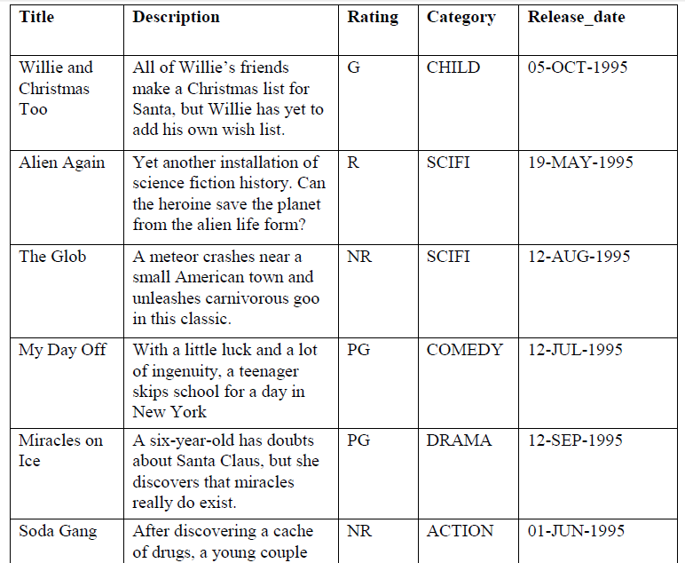



b. Add data to the MEMBER table. Place the insert statements in a script named

lab14_4b.sql. Execute commands in the script. Be sure to use the sequence to add the

member numbers.

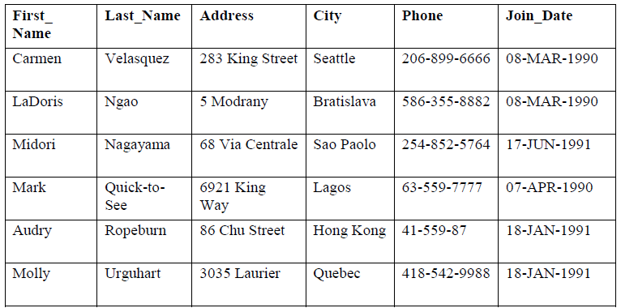

**SET ECHO OFF**

**SET VERIFY OFF**

**INSERT INTO member(member_id, first_name, last_name, address,**

**city, phone, join_date)**

**VALUES (member_id_seq.NEXTVAL, '&first_name', '&last_name',**

**'&address', '&city', '&phone', TO_DATE('&join_date',**

**'DD-MM-YYYY');**

**COMMIT;**

**SET VERIFY ON**

**SET ECHO ON**

c. Add the following movie copies in the TITLE_COPY table:

**Note:** Have the TITLE_ID numbers available for this exercise.

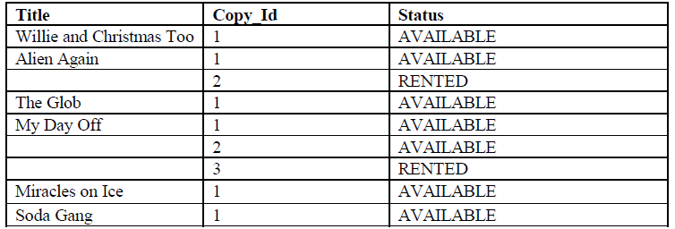

**INSERT INTO title_copy(copy_id, title_id, status)**

**VALUES (1, 92, 'AVAILABLE');**

**INSERT INTO title_copy(copy_id, title_id, status)**

**VALUES (1, 93, 'AVAILABLE');**

**INSERT INTO title_copy(copy_id, title_id, status)**

**VALUES (2, 93, 'RENTED');**

**INSERT INTO title_copy(copy_id, title_id, status)**

**VALUES (1, 94, 'AVAILABLE');**

**INSERT INTO title_copy(copy_id, title_id, status)**

**VALUES (1, 95, 'AVAILABLE');**

**INSERT INTO title_copy(copy_id, title_id,status)**

**VALUES (2, 95, 'AVAILABLE');**

**INSERT INTO title_copy(copy_id, title_id,status)**

**VALUES (3, 95, 'RENTED');**

**INSERT INTO title_copy(copy_id, title_id,status)**

**VALUES (1, 96, 'AVAILABLE');**

**INSERT INTO title_copy(copy_id, title_id,status)**

**VALUES (1, 97, 'AVAILABLE');**

d. Add the following rentals to the RENTAL table:

**Note:** Title number may be different depending on sequence number.

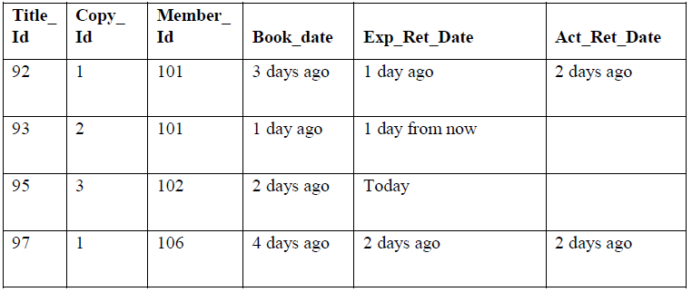

**INSERT INTO rental(title_id, copy_id, member_id,**

**book_date, exp_ret_date, act_ret_date)**

**VALUES (92, 1, 101, sysdate-3, sysdate-1, sysdate-2);**

**INSERT INTO rental(title_id, copy_id, member_id,**

**book_date, exp**_**ret**_**date, act**_**ret**_**date)**

**VALUES (93, 2, 101, sysdate-1, sysdate-1, NULL);**

**INSERT INTO rental(title_id, copy_id, member_id,**

**book_date, exp_ret_date, act_ret_date)**

**VALUES (95, 3, 102, sysdate-2, sysdate, NULL);**

**INSERT INTO rental(title_id, copy_id, member_id,**

**book_date, exp_ret_date,act_ret_date)**

**VALUES (97, 1, 106, sysdate-4, sysdate-2, sysdate-2);**

**COMMIT;**

5. Create a view named TITLE_AVAIL to show the movie titles and the availability of

each copy and its expected return date if rented. Query all rows from the view. Order the results by

title.

**CREATE VIEW title_avail AS**

**SELECT t.title, c.copy_id, c.status, r.exp_ret_date**

**FROM title t, title_copy c, rental r**

**WHERE t.title_id = c.title_id**

**AND c.copy_id = r.copy_id(+)**

**AND c.title_id = r.title_id(+);**

**SELECT \***

**FROM title_avail**

**ORDER BY title, copy_id;**

6. Make changes to data in the tables.

a. Add a new title. The movie is “Interstellar Wars,” which is rated PG and classified as a

scifi movie. The release date is 07-JUL-77. The description is “Futuristic interstellar

action movie. Can the rebels save the humans from the evil empire?” Be sure to add a title

copy record for two copies.

**INSERT INTO title(title_id, title, description, rating,**

**category, release_date)**

**VALUES (title_id_seq.NEXTVAL, 'Interstellar Wars',**

**'Futuristic interstellar action movie. Can the**

**rebels save the humans from the evil Empire?',**

**'PG', 'SCIFI', '07-JUL-77');**

**INSERT INTO title_copy (copy_id, title_id, status)**

**VALUES (1, 98, 'AVAILABLE');**

**INSERT INTO title_copy (copy_id, title_id, status)**

**VALUES (2, 98, 'AVAILABLE');**

b. Enter two reservations. One reservation is for Carmen Velasquez, who wants to rent

“Interstellar Wars.” The other is for Mark Quick-to-See, who wants to rent “Soda Gang.”

**INSERT INTO reservation (res_date, member_id, title_id)**

**VALUES (SYSDATE, 101, 98);**

**INSERT INTO reservation (res_date, member_id, title_id)**

**VALUES (SYSDATE, 104, 97);**

c. Customer Carmen Velasquez rents the movie “Interstellar Wars,” copy 1. Remove her

reservation for the movie. Record the information about the rental. Allow the default

value for the expected return date to be used. Verify that the rental was recorded by using

the view you created.

**INSERT INTO rental(title_id, copy_id, member_id)**

**VALUES (98,1,101);**

**UPDATE title_copy**

**SET status= 'RENTED'**

**WHERE title_id = 98**

**AND copy_id = 1;**

**DELETE**

**FROM reservation**

**WHERE member_id = 101;**

**SELECT \***

**FROM title_avail**

**ORDER BY title, copy_id;**

7. Make a modification to one of the tables.

a. Add a PRICE column to the TITLE table to record the purchase price of the video. The

column should have a total length of eight digits and two decimal places. Verify your

modifications.

**ALTER TABLE title**

**ADD (price NUMBER(8,2));**

**DESCRIBE title;**

b. Create a script named lab14_7b.sql that contains update statements that update each

video with a price according to the following list. Run the commands in the script.

**Note:** Have the TITLE_ID numbers available for this exercise.

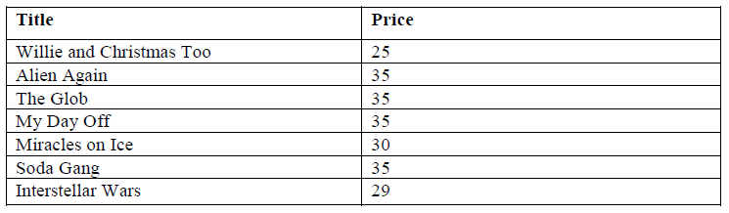

**SET ECHO OFF**

**SET VERIFY OFF**

**DEFINE price=**

**DEFINE title_id=**

**UPDATE title**

**SET price = &price**

**WHERE title_id = &title_id;**

**SET VERIFY OFF**

**SET ECHO OFF**

c. Ensure that in the future all titles contain a price value. Verify the constraint.

**ALTER TABLE title**

**MODIFY (price CONSTRAINT title_price_nn NOT NULL);**

**SELECT constraint_name, constraint_type,**

**search**_**condition**

**FROM user_constraints**

**WHERE table_name = 'TITLE';**

8. Create a report titled Customer History Report. This report contains each customer's

history of renting videos. Be sure to include the customer name, movie rented, dates of the

rental, and duration of rentals. Total the number of rentals for all customers for the reporting

period. Save the commands that generate the report in a script file named lab14_8.sql*.*

**SET ECHO OFF**

**SET VERIFY OFF**

**TTITLE 'Customer History Report'**

**BREAK ON member SKIP 1 ON REPORT**

**SELECT m.first_name||' '||m.last_name MEMBER, t.title,**

**r.book_date, r.act_ret_date - r.book_date DURATION**

**FROM member m, title t, rental r**

**WHERE r.member_id = m.member_id**

**AND r.title_id = t.title_id**

**ORDER BY member;**

**CLEAR BREAK**

**TTITLE OFF**

**SET VERIFY ON**

**SET ECHO ON**